Canon image RUNNER 6000

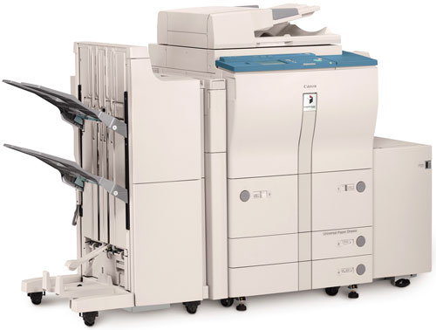

Image RUNNER 6000 Specifications
Type : Digital, Multifunction Imaging System
Imaging System : Laser Dry Electrostatic Transfer
Developing System : Dry Monocomponent Toner Projection
Image Server Memory : Standard 128MB RAM + 5.1GB HDD
(Max. Capacity : Approximately 4,000 Originals)
First-copy Time : 3.8 Seconds from Platen Glass
5.1 Seconds from ADF
Warm-up Time : 6 Minutes or Less
Acceptable Originals : Sheets, Books, 3 Dimensional
Items (Up to 4.4 lb.)
Max. Original Size : 11" x 17" (Ledger)
Max. Copy Size : 11" x 17" (Ledger)
Min. Copy Size : 4-1/8" x 5-7/8"
Max. Mail Boxes Supported : 100
Max. Copy Reservation : 5 Jobs
Copy/Scanning Resolution : 600 dpi x 600 dpi
Printing Resolution : 600 dpi x 600 dpi
2400 dpi x 600 dpi Interpolated
Halftone : 256 Gradations of Gray
Copy Speed : 60 cpm (Letter)
42 cpm (Letter-R)
36 cpm (Legal)
30 cpm (Ledger)
Duplexing : Standard Automatic Tray less
Magnification Reduction/
Enlargement : 25% to 400% in 1% Increments
Standard : Dual Front-loading Trays
(1,500 Sheets Each)
Dual Front-loading Cassettes
(550 Sheets Each)
50-sheet Stack Bypass Optional : 3,500-sheet Paper Deck
(Total: 7,650 Sheets)
Multiple Copies : 1 to 999
Paper Weights : 17 lb. to 24 lb. Bond
(550-sheet Cassettes)
17 lb. to 110 lb. Index
(Manual Bypass, 1,500-sheet
Drawers and 3,500-sheet optional
Supplies
Drum : Amorphous Silicon – Estimated
Yield : 3,000,000 Impressions
Maximum Duty Cycle : 230,000 Impressions per Month
Toner : Magnetic Negative Toner –
Estimated Yield : 33,000 Images
(at 6% coverage)
Accessories
Automatic Document Feeder (Standard)
Acceptable Originals : Statement to Ledger
Capacity : 100 Sheets (LTR/20 lb.)
Max. Paper Weight : Up to 32 lb. Bond (LTR)

We are the canon Rc1 Dealers in Bangalore contact: canonrc1bangalore@gmail.com 9060002096 .9945457636.9880988731

